**Task 8 – Movie Ticket Price**

**Algorithm**• Get user age using prompt() and convert to number.

• Ask if the user is a student (yes or no) using prompt(), then convert to boolean.

• Use if-else or logical conditions to:

* If age < 5 or age > 65 → price = $5
* If age between 5–18 **and** student → price = $8
* Else → price = $12

• Display ticket price using console.log() and alert().

**Psudocode**START

PROMPT for age → convert to number

PROMPT for student status (yes/no) → convert to boolean

DISPLAY inputs in console

IF age < 5 OR age > 65

price = $5

ELSE IF age between 5 and 18 AND isStudent == true

price = $8

ELSE

price = $12

DISPLAY price using console and alert

END

**Code(javascript)  
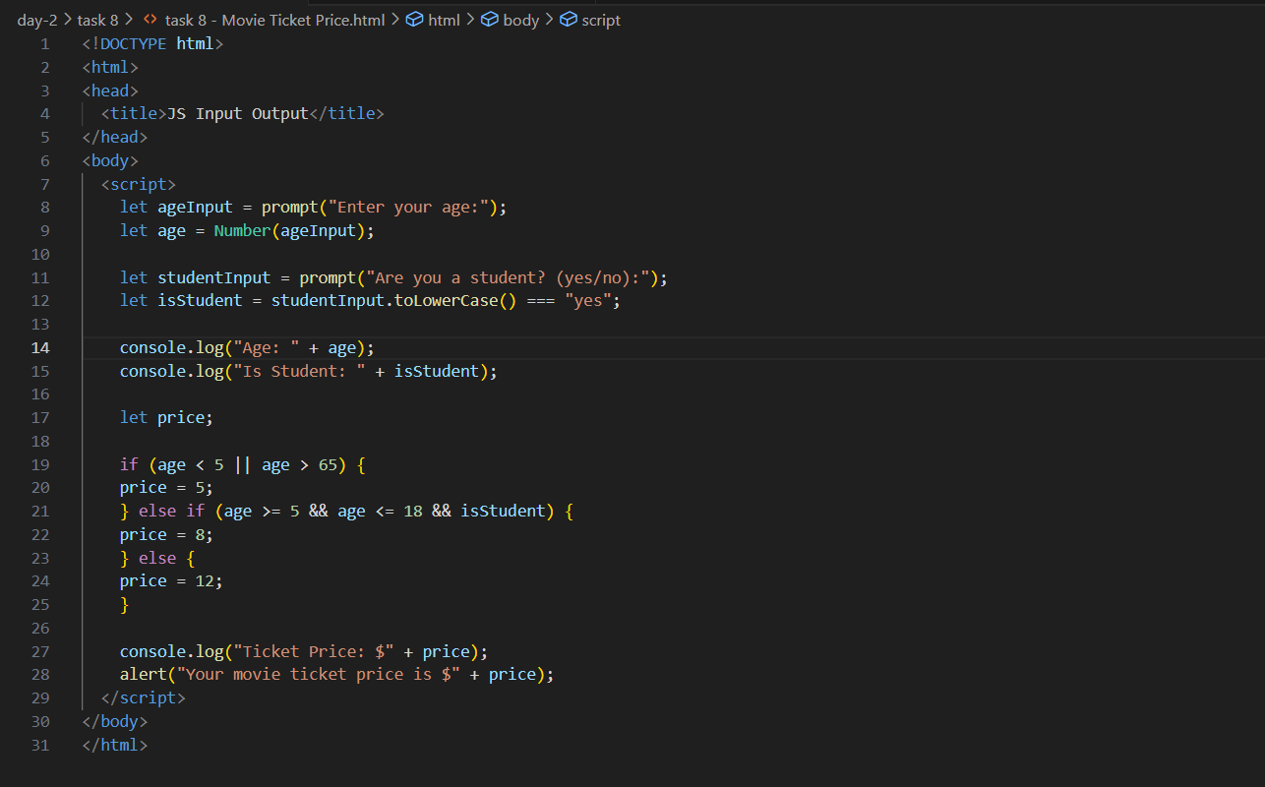**

**Output (test case 1)**

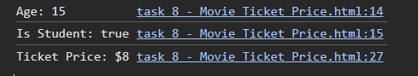  
**Output (test case 2)**  
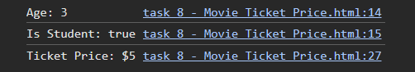

**Output (test case 3)**

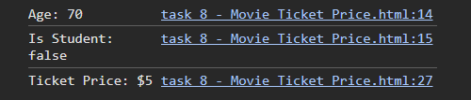

**Observations**

* Combines both **logical operators** (||, &&) and **type conversion** from string to boolean.
* Clearly separates conditions for all age and student status categories.
* Helps understand nested condition evaluation and practical use of prompt() + alert().
* A solid example of multi-branch logic for real-world decision systems.